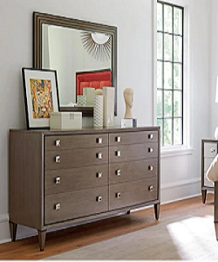

Dressing Table

$116.99

Availability: In stock

Description:

This is brown vanity table. Its ravishing appearance will prove to be the perfect addition to your living. Although it looks very humble, how many women are captured their heart. Crafted with 8 drawers, includes space to store needed things.